Three Dimensional Figures Day 4 (12.4)
Surface Area of Pyramids
Geometry

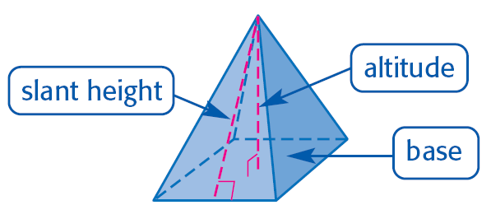
Parts of a pyramid:
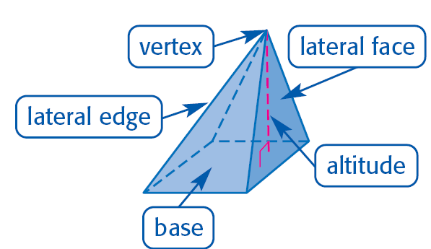

Lateral Area of a Pyramid: __________________________________________________________________

L = _______________ P = _____________________ l =_____________________

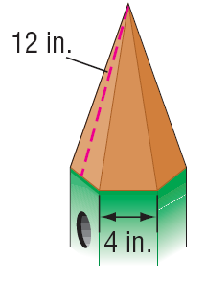
Example 1: Find the lateral area of the _____________________________.

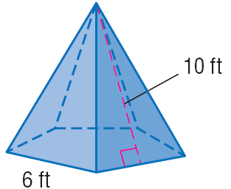
Example 2: Find the lateral area of the _____________________________.

Example 3: Find the lateral area of the _____________________________.
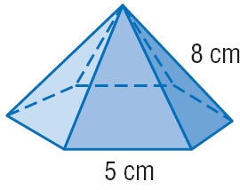
Surface Area of a Pyramid: T=___________________

P =__________________________ l=____________________________ B=____________________

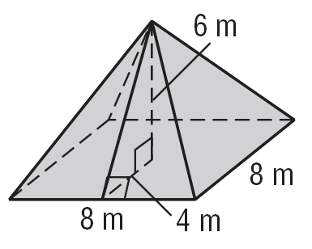
Example 4: Find the Total Surface Area of the _____________________________.

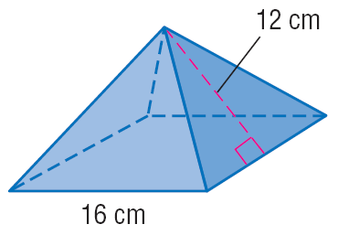
Example 5: Find the Total Surface Area of the _____________________________.

Example 6: Find the Total Surface Area of the _____________________________.


