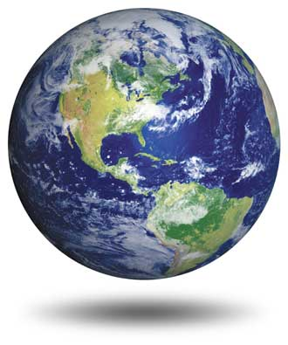
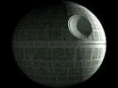
12.6 Surface Area of Spheres
13.3 Volume of Spheres

Goal: Recognize and define basic properties of spheres.
Goal: Find the surface areas of spheres.
Goal: Find the volumes of spheres.

Sphere: _____________________________________________________________________
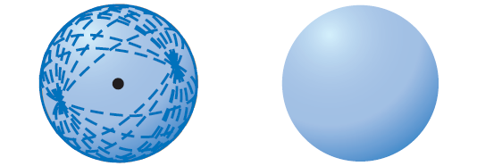

Intersections of a Plane and a Sphere:

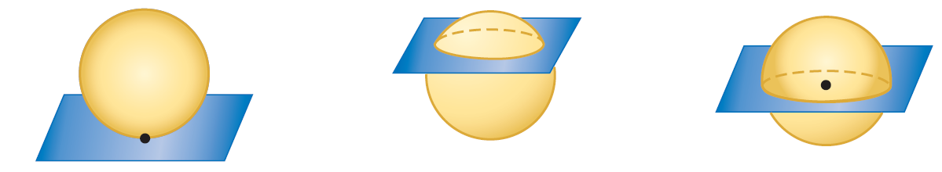

________________ ________________ ________________

Great Circle: _________________________________________________________________

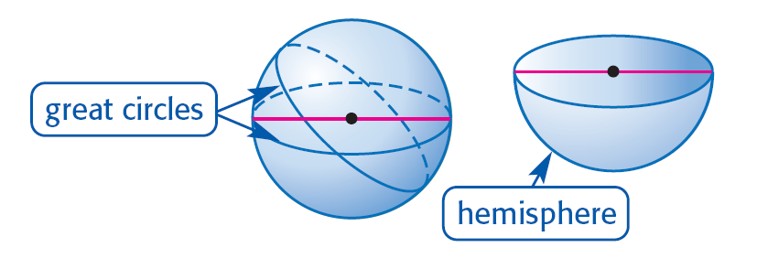
Hemisphere: _________________________________________________________________

Lateral Area of a Sphere: _______________

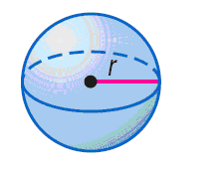
Surface Area of a Sphere: _______________________________________

T = ___________________ r = ___________________

Example 1: Find the surface area of a regulation men’s basketball (diameter = 9.39 in).
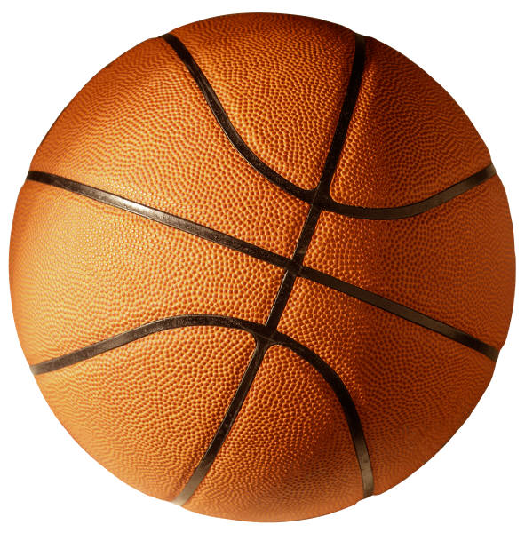

Example 2: Find the surface area of a regulation sized baseball with an approximate diameter of 2.9 inches.

Example 3: In the figure, O is the center of the sphere, and plane P intersects the sphere in circle R. If OR = 6 centimeters and OS = 14 centimeters, find RS.
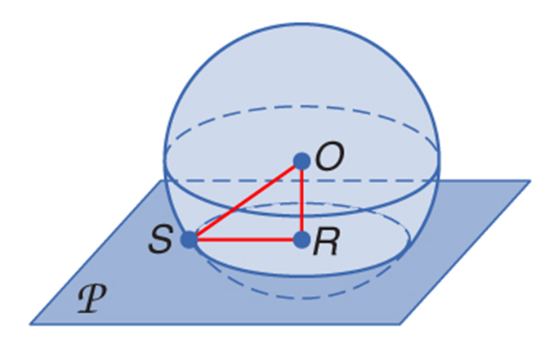

Example 4: Find the surface area of the sphere, given a great circle with an area of approximately 907.9 square centimeters.

Volume of a Sphere: _______________________________________________________

V = ______________________ r = _____________________

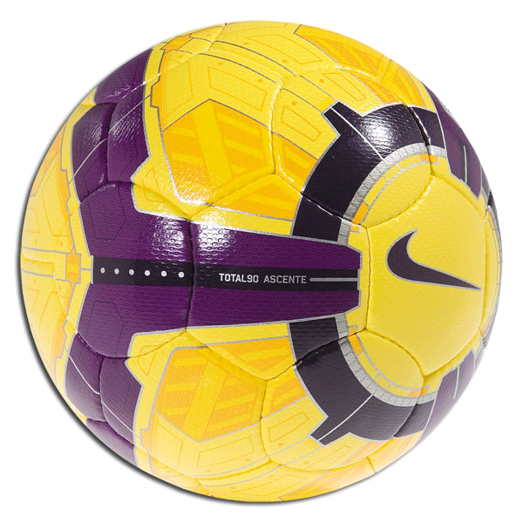
Example 5: Find the volume of a regulation size soccer ball with an approximate diameter of 8.75 inches.

Example 6: Find the surface area and volume of a hemisphere with a radius of 3.8 inches.
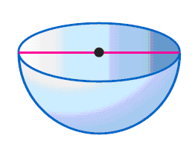

Example 7: The surface area of sphere is 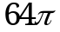square meters. Calculate the radius and volume of the sphere.

Example 8: Spaceship Earth is a geodesic sphere, standing 180 feet tall & 165 feet in diameter & weighing an estimated 16 million pounds. Calculate the total surface area and volume of the spherical portion of Spaceship Earth.


